

**Receiver vibration of hearing aid stability FEA model**

|  |  |  |  |
| --- | --- | --- | --- |
| ORIGINATOR: |  | DATE |  |
| Yu Luan |  | 22-07-2016 |  |
| Last changed by: |  |  |  |
|  |  |  |  |
| Reviewed by: |  |  |  |
|  |  |  |  |



|  |  |  |  |  |
| --- | --- | --- | --- | --- |
| Document Revision History | | | | |
| Change  Order  Type & # | REV | Effectivity  Date (DMY) | Change  Owner | Change Description |
|  |  | 22-07-2016 | Yu Luan | Document started |
|  |  |  |  |  |
|  |  |  |  |  |
|  |  |  |  |  |
|  |  |  |  |  |
|  |  |  |  |  |
|  |  |  |  |  |
|  |  |  |  |  |
|  |  |  |  |  |
|  |  |  |  |  |
|  |  |  |  |  |
|  |  |  |  |  |
|  |  |  |  |  |
|  |  |  |  |  |
|  |  |  |  |  |
|  |  |  |  |  |

Contents

Introduction 3

1. Import measured receiver housing vibration into Abaqus model 3

1.1 Get U and UR on reference point of receiver 4

1.2 Get RFs and RMs on reference point of receiver 5

1.3 Use RFs and RMs, and check displacements on surfaces of receiver. 6

2 Calibrate receiver membrane vibration 6

2.1 Initial membrane vibration 6

2.2 Adjust membrane vibration 7

Appendix 8

# Introduction

Hearing aid stability FEA model in Abaqus contains all mechanical parts, air inside acoustic channel from receiver to coupler and air outside the hearing aid. See Figure 1.Some of the parts are lumped, e.g., receiver and microphones. The model calculates the acoustical feedback at microphone positions with applied receiver vibration – housing vibration (mechanical vibration) and membrane vibration (acoustical vibration). Since the inside components of receiver is not given by supplier, we have to make a lumped model for receiver vibration, that is divided into housing and membrane vibrations, respectively. This document illustrates how the receiver vibrations are measured and imported into Abaqus model. All data can be found in the excel file in the Appendix.

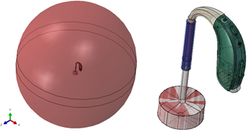

Figure 1 Hearing aid stability model (Abaqus). To the left is the whole model. To the right is a zoom in without air out of hearing aid.

# Import measured receiver housing vibration into Abaqus model

This section shows how the receiver housing vibration is applied in Abaqus model. Receiver housing vibration is measured and converted to reaction force and moment at the center of mass.

It is not difficult to measure the receiver housing vibration. However, if the measured vibration is applied in Abaqus model, it will not be valid. The reason is that the suspension in each design are mostly likely different from experimental setup. Therefore, we calculate the reaction forces and reaction moments at the center of mass of receiver with an experimental setup that give free receiver vibration with proper acoustic load. This is to get the heartbeat of a free receiver. The obtained reaction forces and moments will then be able to be applied in models that has different suspension system than experimental setup.

The experimental setup is shown in Figure 2. The acoustic load is similar to real BTE load with 2cc coupler. The tube that connects to receiver spout is very soft, which gives around 300 Hz fundamental frequency of the receiver-suspension system, and therefore, the receiver vibrates freely from 300 Hz and above. The measured data are velocities on three receiver surfaces – normal to membrane, side to membrane, and spout direction. On each surface, three positions are measured. The velocity is normalized by driving voltage at receiver terminals, and then converted to displacement on each measurement point.

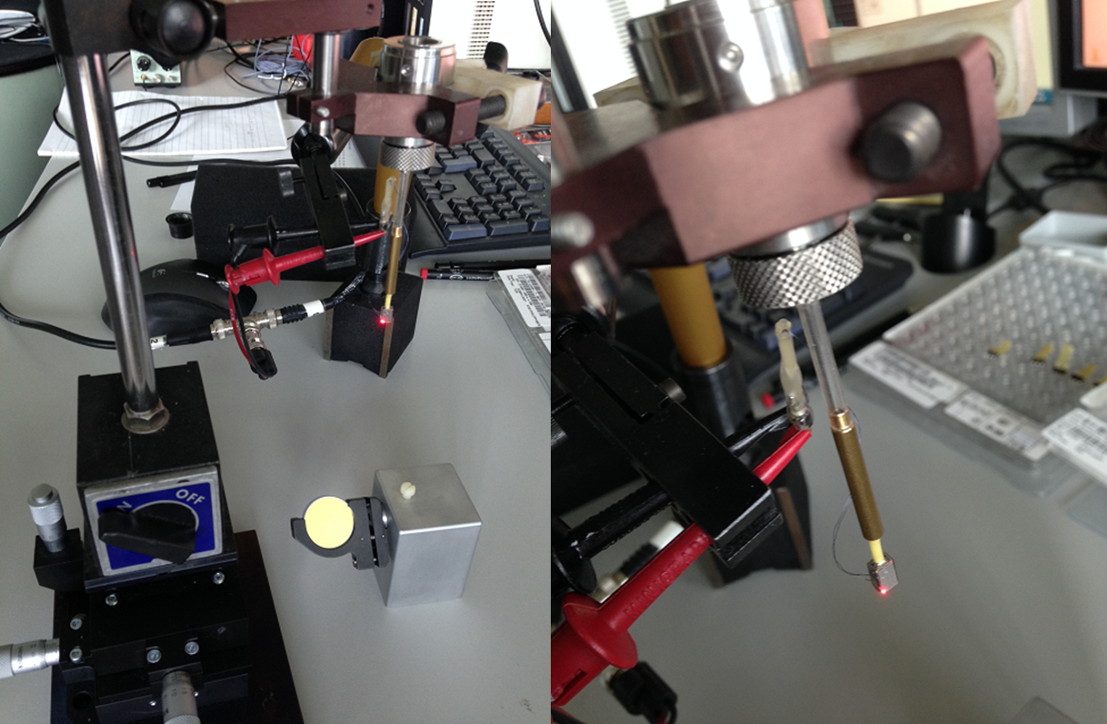

Figure 2 Receiver housing vibration measurement

The receiver in Abaqus model is a rigid body of housing shell, which does not contain any component details. It has given values by supplier: outside geometry, mass and moment of inertia at the center of mass. In the following, three steps are illustrated to obtain the reaction forces and moments at the center of mass of receiver.

## Get U and UR on reference point of receiver

Apply measured displacement load on 9 points (3 points on each of the 3 receiver surfaces) to calculate the translation and rotation displacements (U and UR) on center of mass (CM) of Receiver in three directions in local coordinate system. See Figure 3.

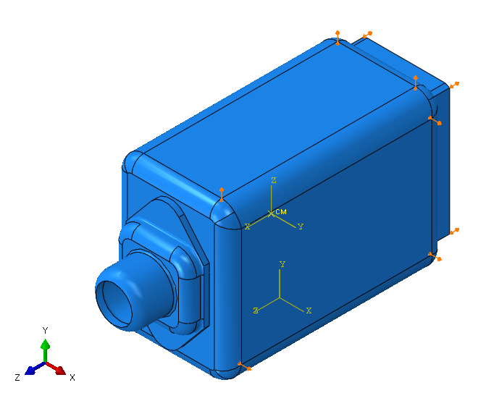

Figure 3 Input measured displacement in Abaqus receiver model

In order to get the U and UR at the center of mass, the node of CM has to be coupled to receiver body. For this purpose, rigid body cannot be used in this step. Instead, the Young’s modulus of housing material is set to be extremely high to assume a rigid housing.

## Get RFs and RMs on reference point of receiver

Apply the obtained translation and rotation displacements in three directions on center of mass of receiver to get reaction forces and moments (RFs and RMs). See Figure 4. Starting from this step, receiver rigid body is used.

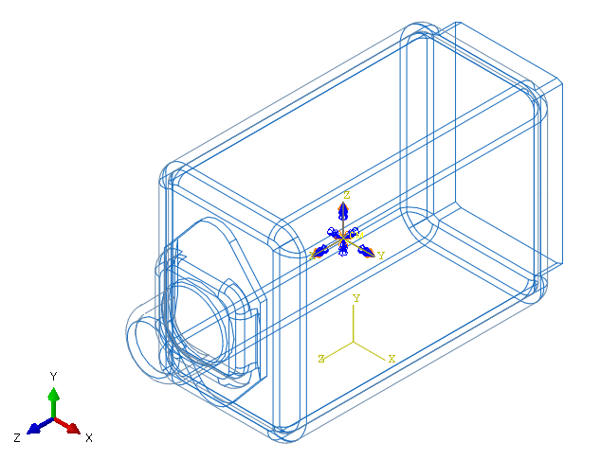

Figure 4 Apply U and UR at center of mass.

## Use RFs and RMs, and check displacements on surfaces of receiver.

Apply the obtained RFs and RMs on CM of Receiver, and check displacement on receiver surfaces. The data on all 9 points should all match the measurement. Figure 5 is an example of data at one point on receiver housing.

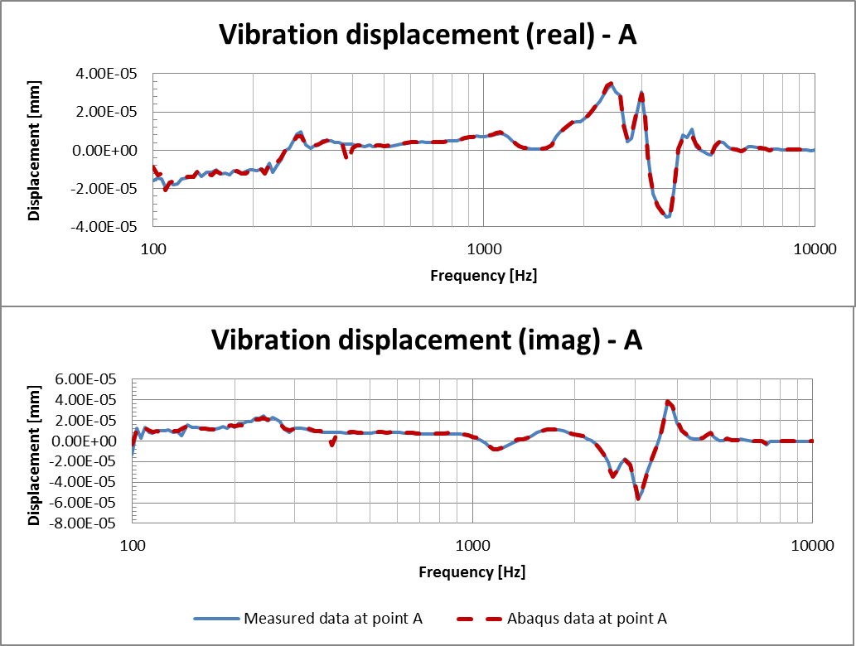

Figure 5 Receiver housing vibration at one point. Measurement vs Abaqus.

Now, the reaction forces and moments at the center of mass of receiver is obtained and approved. They will be used as mechanical vibration input in the hearing aid stability model.

# Calibrate receiver membrane vibration

The acoustic vibration source in the stability model is independent to the mechanical vibration in receiver level. The receiver membrane is modeled as a piston attached on the air volume in receiver. It has no contact to receiver housing. Membrane velocity is equalized to give the coupler pressure that matches measured coupler pressure in 2cc coupler. The equalization also takes the mechanical vibration of structures into account. In other words, the structure borne sound from receiver housing vibration to coupler pressure is also added into the calculation. Therefore, the final model using the equalized receiver membrane velocity gives a coupler pressure that matches experimental data.

|  |
| --- |
| Initial membrane vibration |
| Initial membrane velocity is applied as the main acoustic source to get coupler pressure. Also, the receiver housing vibration is also apply alongside to give extra sound pressure, which is radiated by air tunnel walls (e.g. suspension walls), and travels in the air tunnel to 2cc coupler. The initial receiver membrane velocity is  The receiver housing vibration is simulated in the model using the RFs and RMs at receiver center of mass. |
| Adjust membrane vibration |
| The coupler pressure obtained with the initial membrane velocity and housing vibration is then compared to experimental data to get an equalization factor:  . (1)  Here,  is the experimental data of coupler pressure, and is the coupler pressure in Abaqus model with initial membrane velocity. Complex numbers are used to include both amplitude and phase into the calculation. The equalized membrane velocity is then calculated to be the product of initial velocity and equalization factor.  (2)  By applying the equalized receiver membrane velocity together with housing vibration, the coupler pressure is obtained. Figure 6 shows the coupler pressure curves: Measurement, Abaqus with initial membrane velocity, and Abaqus with equalized membrane velocity. Note that the velocity is converted to displacement to be used in Abaqus. The green dotted line (Abaqus with equalized velocity) is spot on the measured curve for both amplitude and phase. It indicates that the equalization works, and the equalized velocity is ready to be used in future FEA models of whole hearing aid. |
|  |

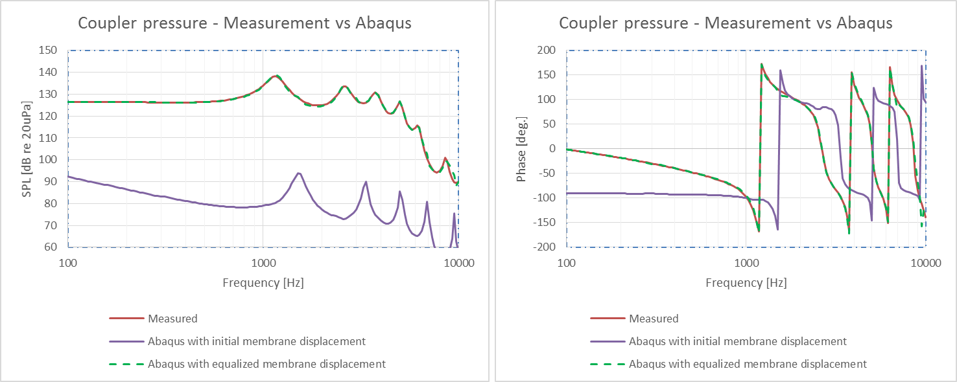

Figure 6 Coupler pressure - measured vs Abaqus with initial/equalized receiver membrane velocity (displacement)

The receiver housing vibration is transmitted to air tunnel walls as structure-borne sound, and therefore, the tunnel walls radiate sound into air tunnel and 2cc coupler. It is difficult to measure how much the housing vibration results in coupler pressure. However, it can be simulated in FEA models. By applying only the housing vibration in the model, the coupler pressure is obtained as the purple curve in Figure 7. It is neglect able compare to the coupler pressure that is caused by receiver membrane vibration (dotted green curve). The red curve is coupler pressured with both housing and membrane vibration. Actually, the dotted green curve is almost identical to the red curve.

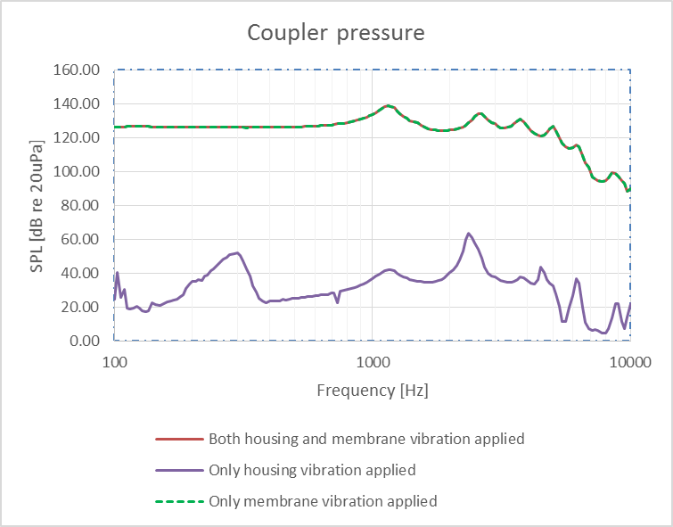

Figure 7 Coupler pressure with different vibration source

# Appendix

